Design and Analysis of Algorithms Lab Assessment-2

Name: Armaan Indani

Reg. No.: 22BCE3347

Slot : L41+42

Faculty: Dr. Joshva Devdas T – 16700

**Question 1: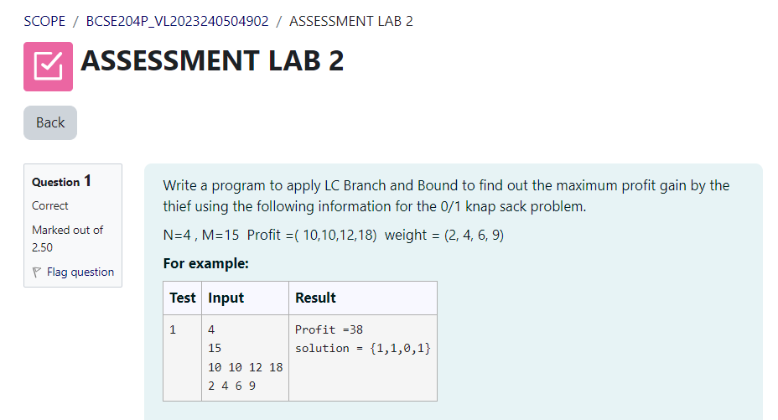 **

**Question 2**

**Question 3**

**Question 4**

